Documentation

Task 1 – Acquisition
First we perform acquisition of GPS signals from raw front-end data. Our code searches for signals from satellites specified in the settings structure by correlating the incoming signal with locally generated C/A codes. The function first processes the input signal (potentially resampling it to speed up acquisition), then performs a two-step acquisition process: a coarse search across frequency bins and code phases, followed by a fine resolution frequency search for detected signals. For each satellite, it calculates the correlation peak ratio to determine if a signal is present, and if found, it stores the code phase and carrier frequency in the output structure.

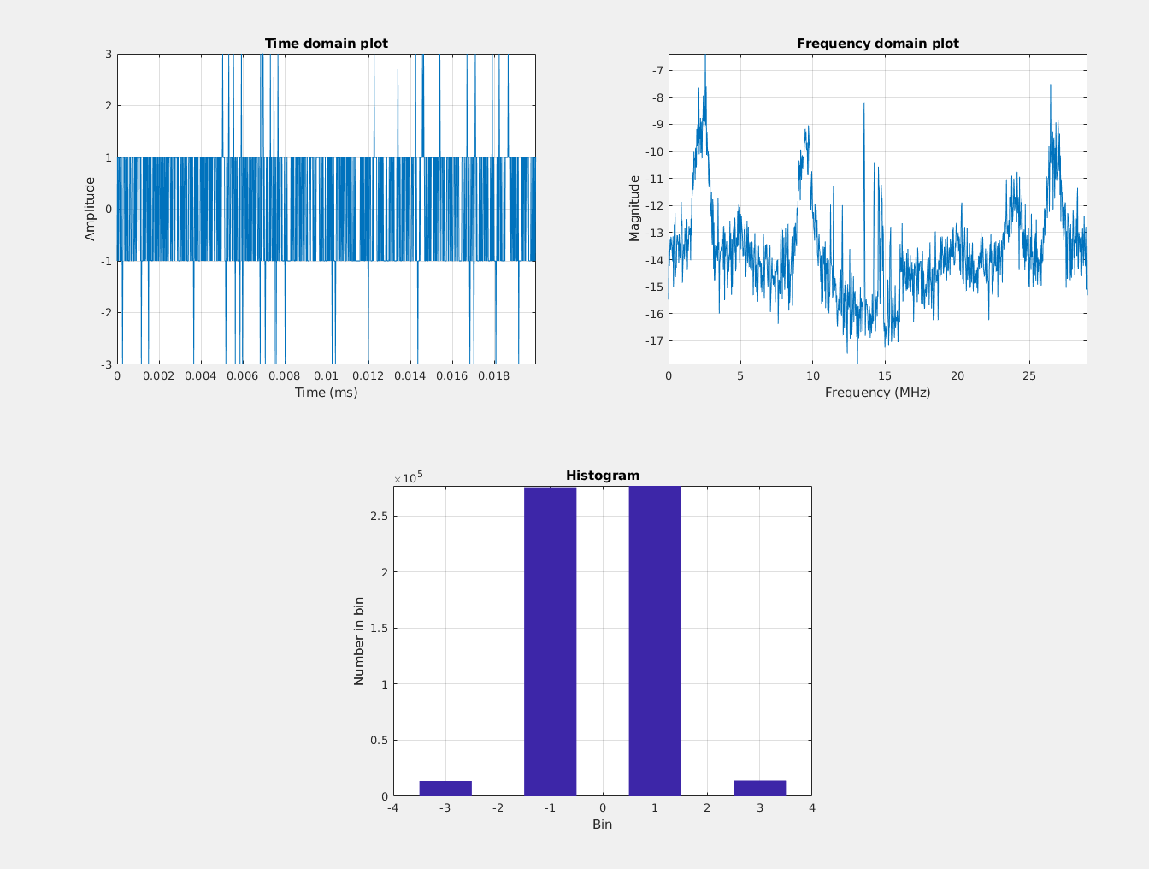

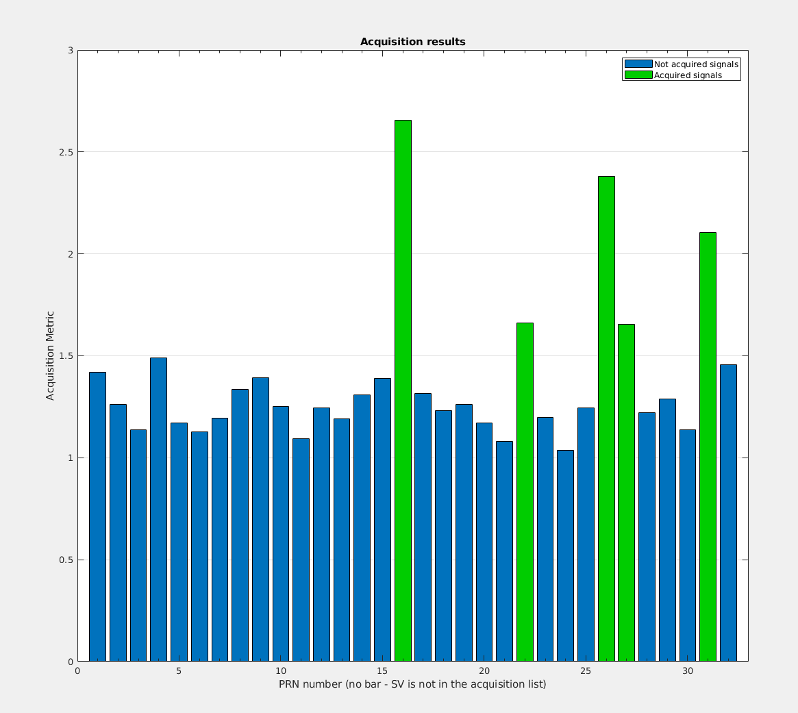

Task 2 – Tracking
Adapt the tracking loop (DLL) to generate correlation plots and analyze the tracking performance. Discuss the impact of urban interference on the correlation peaks. (Multiple correlators must be implemented for plotting the correlation function.)

Then we perform tracking of GPS signals for channels identified by the acquisition process. We implement both code tracking (DLL - Delay Lock Loop) and carrier tracking (PLL - Phase Lock Loop) to follow the signal as it changes over time. For each channel with an assigned PRN, the function generates local replicas of early, prompt, and late versions of the C/A code, mixes the incoming signal to baseband using carrier wave estimates, and calculates correlation values. These correlation values feed into discriminators that determine tracking errors, which are then filtered and used to adjust the code and carrier frequency estimates in a feedback loop. The function collects tracking metrics throughout processing, including signal strength (C/No), correlator outputs, and loop discriminator values, updating a progress bar every 50ms. The output structure contains detailed tracking results for each millisecond of processing across all active channels.

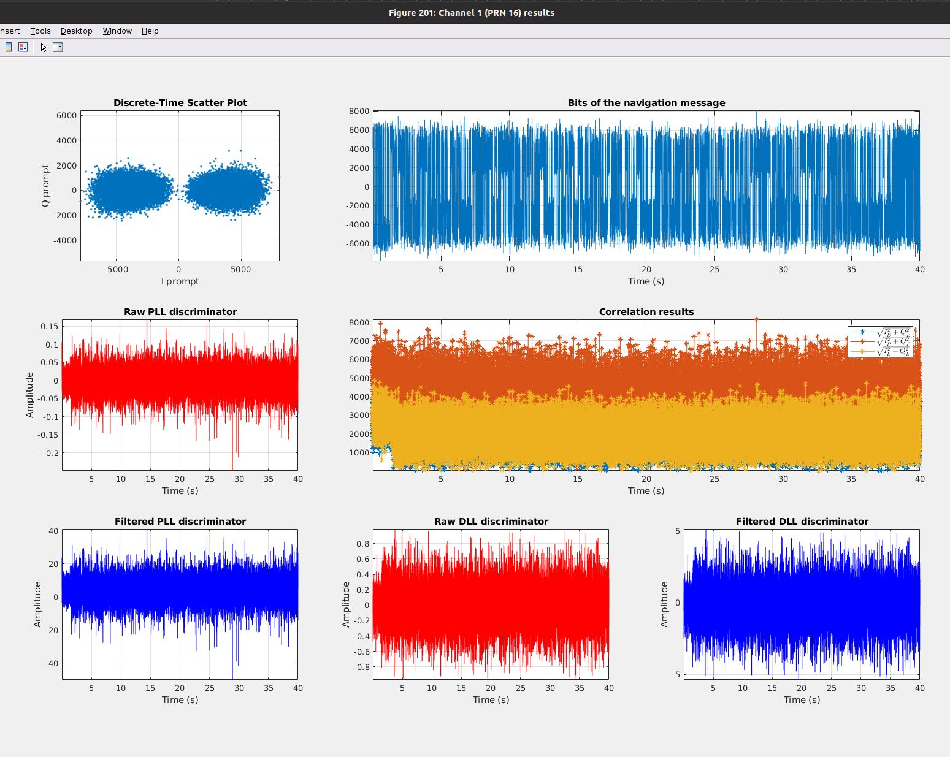

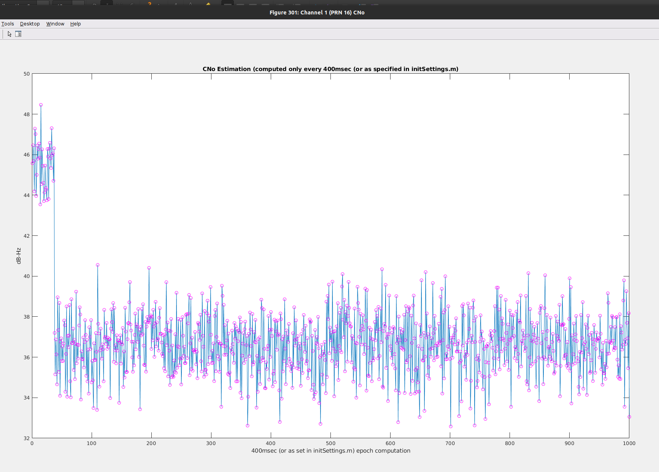

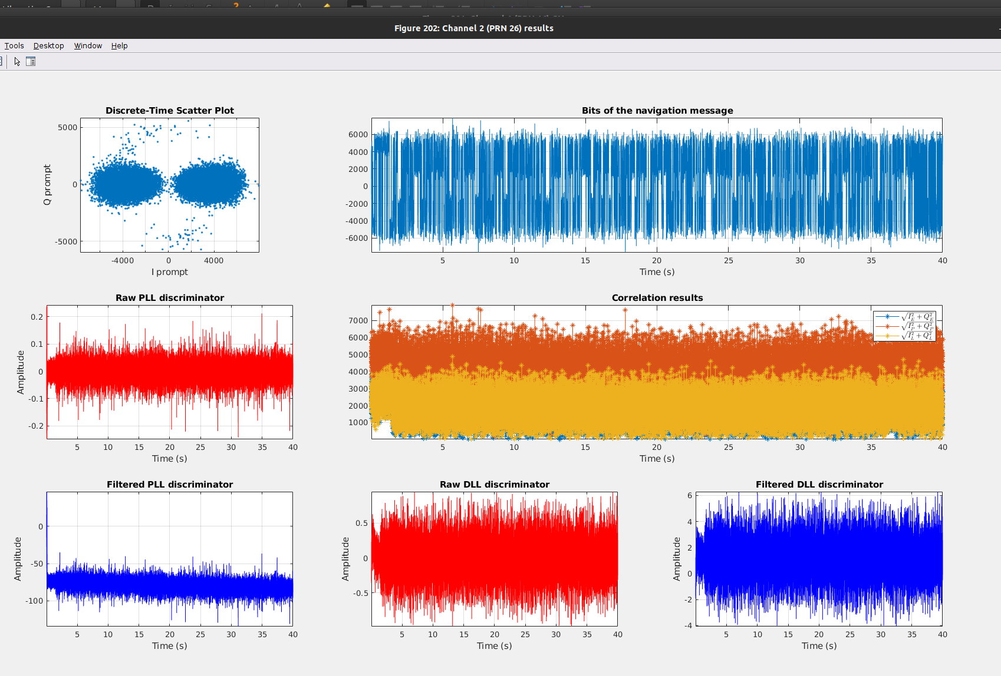

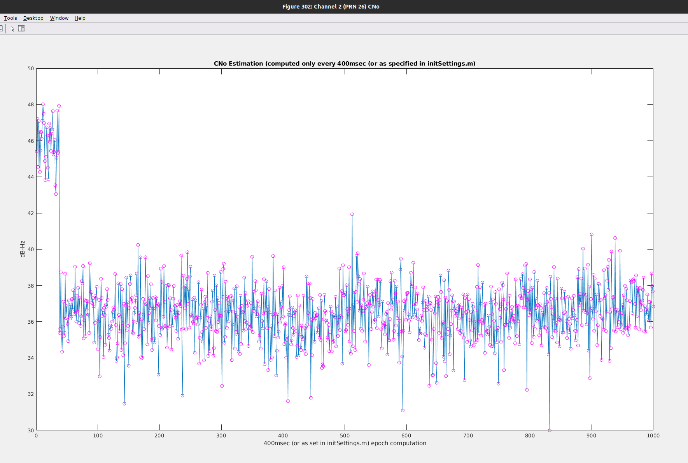

Task 3 – Navigation Data Decoding
Decode the navigation message and extract key parameters, such as ephemeris data, for at least one satellite.

The navigation part of our code takes tracking results for GPS satellites and calculates navigation solutions for the receiver. It first decodes ephemeris data from navigation messages in the tracking results, keeping only channels with complete ephemeris information. The function then processes measurement points sequentially, calculating pseudoranges between satellites and receiver at each point by comparing transmit and receive times. It determines satellite positions and clock corrections using the ephemeris data, then uses least squares estimation to solve for the receiver's position and clock error based on pseudorange measurements. For each valid position fix, the function converts the ECEF (Earth-Centered, Earth-Fixed) coordinates to geodetic (latitude, longitude, height) and UTM (Universal Transverse Mercator) coordinates, and calculates DOP (Dilution of Precision) values to indicate solution quality. The algorithm also applies satellite elevation masking, excluding satellites below a specified elevation angle from position calculations.

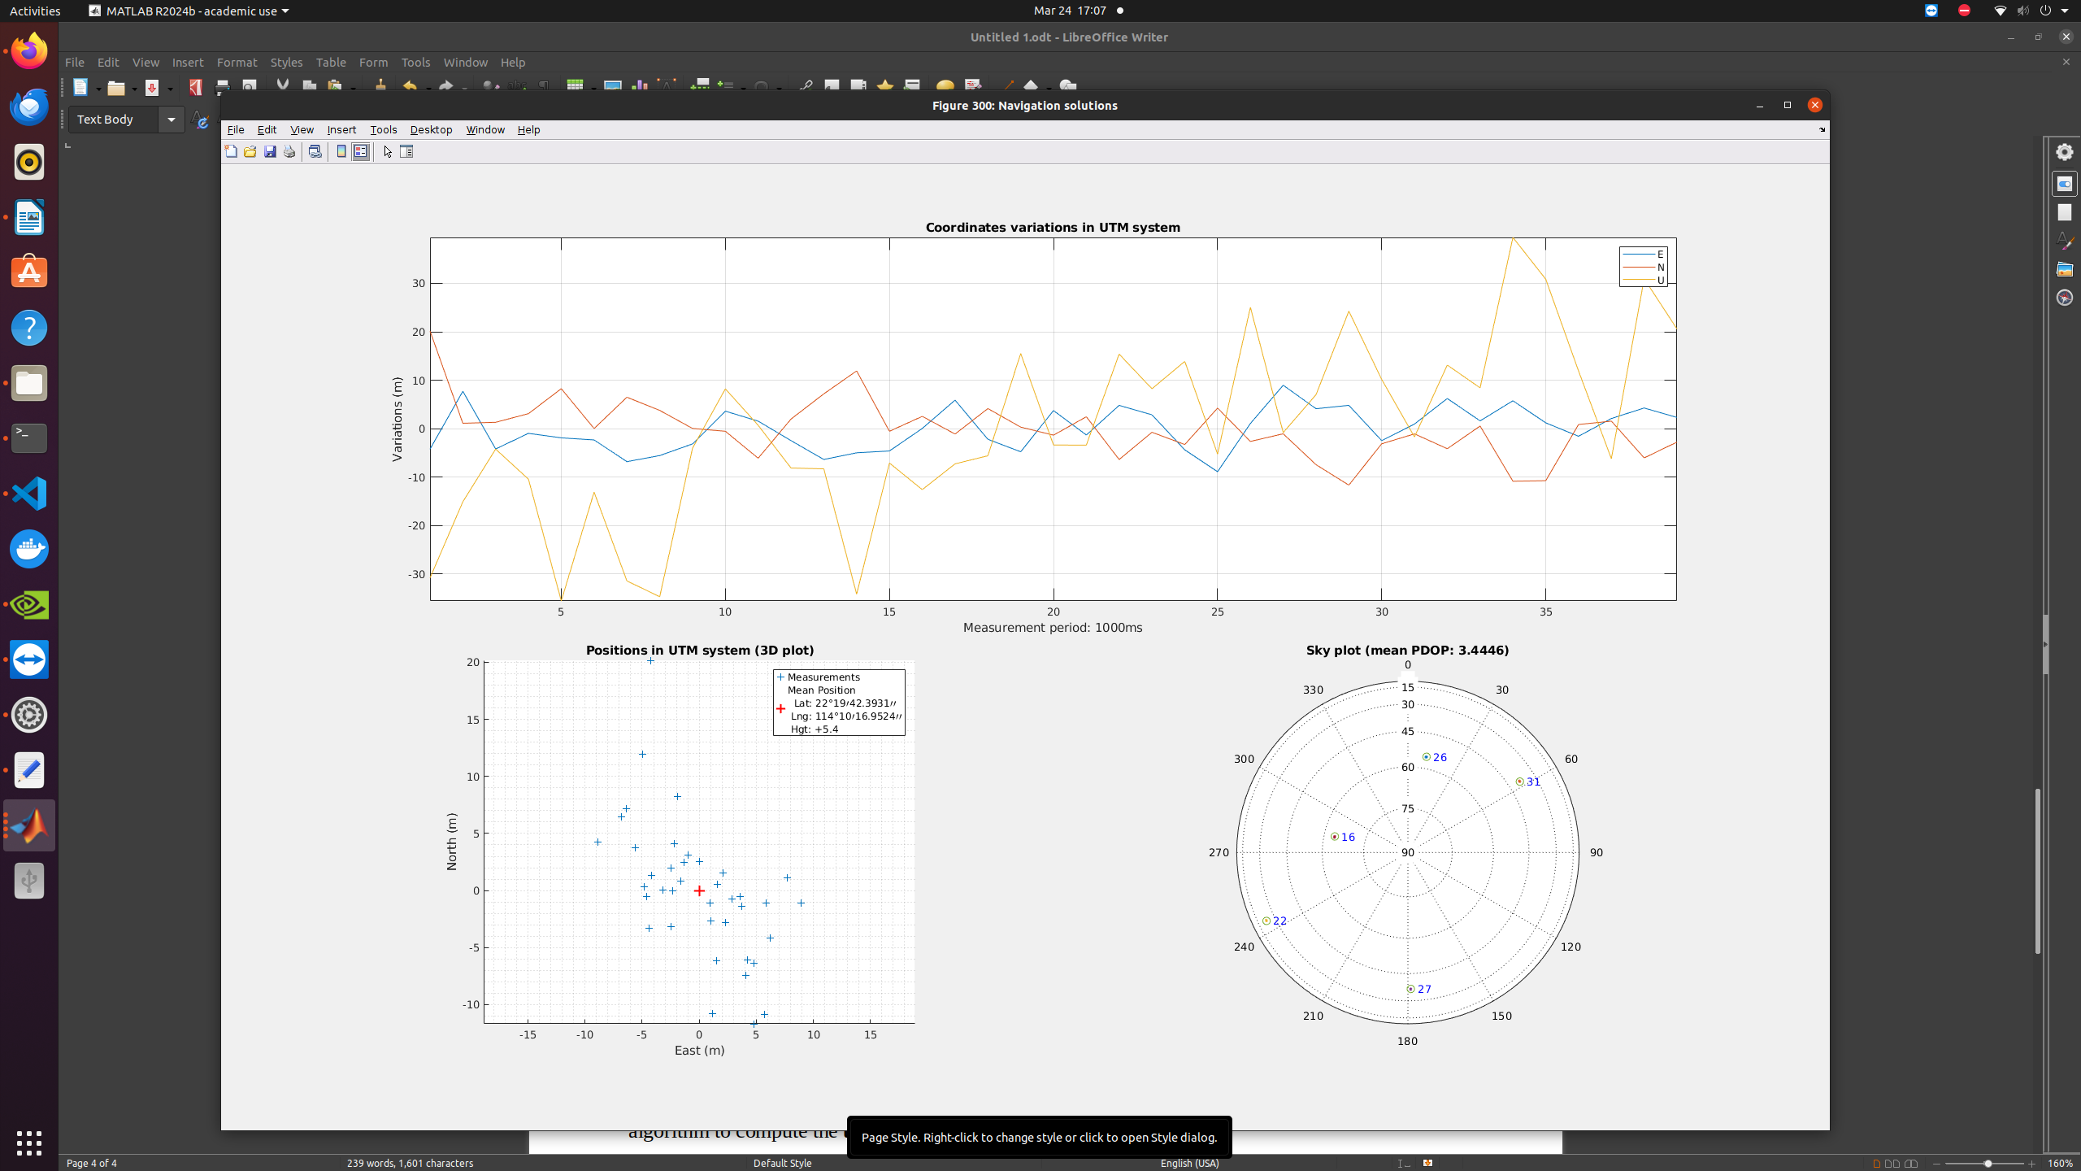

Task 4 – Position and Velocity Estimation
Using pseudorange measurements from tracking, implement the Weighted Least Squares (WLS) algorithm to compute the user's position and velocity.
- Plot the user position and velocity.
- Compare the results with the ground truth.
- Discuss the impact of multipath effects on the WLS solution.

Task 5 – Kalman Filter-Based Positioning
Develop an Extended Kalman Filter (EKF) using pseudorange and Doppler measurements to estimate user position and velocity.

Urban:



